Christianity: Background, Basic Beliefs, and Sacred Texts
How did Christianity begin?
Christianity traces its beginning to the miraculous birth, adult ministry, death and resurrection of Jesus of Nazareth, known as Jesus Christ. Over 2000 years ago in Palestine (today's Israel), Jesus was born into a humble Jewish family. His mother was a young peasant woman named Mary. Christians believe that his father was the Holy Spirit of God, making Jesus both fully human and fully divine. His earliest followers came to believe that he was the Messiah, or messenger, sent by God to free God's people from slavery, sin, and death. God sent his son Jesus in human form so that people would better understand God as a caring and loving parent. Jesus lived and experienced the suffering of humans. Jesus healed the sick and told stories, or parables, and preached sermons that taught what God wanted people to do – to love God with all their hearts and love their neighbors as themselves. Jesus taught by example. By being loving and forgiving himself, Jesus taught others to be loving and forgiving - especially toward those who were considered outcasts in society. This is the central message and style of Jesus' teaching.
Q: What is the main, or central, message of Jesus to his followers? _______________________________
_____________________________________________________________________________________
During his adult ministry, Jesus built up a loyal following, led by his twelve disciples, or students. But, Jesus also made enemies among the religious and political leaders of his time. In the end, these powerful leaders were so threatened by Jesus' growing following that the Roman governor sentenced Jesus to death and had him crucified. The third day after Jesus' death, his followers found his tomb empty and discovered that he had been raised from the dead. Christians believe that the painful sacrifice of Jesus' life on the cross shows how much God loves God's people. Jesus paid with his life on Earth for the sins of the world. Christians believe that in raising Jesus' from the dead, God showed that Jesus' message of love and forgiveness was more powerful than death, and that believing in Jesus and following the example of his life and his teaching would lead to eternal life after death. The resurrection (rising from the dead) is the sign of God's salvation offered to all people.
Q: What do Christians believe Jesus does by dying on the cross (being crucified)? ___________________
_____________________________________________________________________________________
Q: According to Christians, what does following Jesus’ message lead to? __________________________
_____________________________________________________________________________________

After his resurrection, Jesus Christ's followers spread his message throughout the world, creating the Christian Church. Today there are about two billion Christians living all over the world.
What do Christians believe?
Christians believe that Jesus Christ was the Son of God – fully human and fully divine – and that through believing in him and following his teachings they can inherit eternal life. Christians believe that Jesus died for humanity, that God raised him from the dead, and that Jesus will come again at the end of time. In addition, Christians believe in the Trinity, or the three parts of God: God the Father or Creator, God the Son (Jesus) or Redeemer, and God the Holy Spirit or Sanctifier. The Holy Spirit is God's presence in the world.
Q: What are the three parts of God? _______________________________________________________
The essence of Jesus' teaching comes from the Jewish law he grew up with in the 10 Commandments with and these additional beliefs:
*Love God with all your heart, soul and mind *Love and tolerance of all people
*Life after death was better than that on earth. * You do not have to be rich to be Christian
*Help the poor and sick *God is more powerful than leaders
Q: Which of the beliefs above would cause Christianity to grow, especially among poor peasants?______
_____________________________________________________________________________________
Q: Which of these beliefs could threaten rulers like Roman Emperors? ____________________________
_____________________________________________________________________________________
What are the sacred texts of Christianity?
The sacred text of Christianity is the Holy Bible. The Christian Bible has two parts: the Old Testament which is essentially the Hebrew scripture, or the Torah, of Jesus' time; and the New Testament which contains writings about Jesus Christ and about the early church. The four gospels (a word meaning ‘good news') of the New Testament are accounts of Jesus' life and teaching, of his death and resurrection. The New Testament also contains the Acts of the Apostles, which describes the early growth of the Christian church; the letters of Paul and other important leaders in the early church; the Letter to the Hebrews; and the Book of Revelation. The New Testament teaches that salvation comes through believing in the death and resurrection of Jesus Christ and in following his teachings. It teaches that salvation is a gift God extends freely through Jesus Christ to all people.
Q: What is the sacred text of Christians?___________________________________________________
Q: The Old Testament of the Bible is the same as the _________________________ of Judaism.
Why are there so many different kinds of Christians?
From its beginning with a tiny group of Jesus' followers, Christianity has spread all over the world. Today, it is practiced by two billion people. As with any large group, Christianity has experienced many different interpretations, disagreements and struggles for power over the centuries. These have led to the growth of many different branches of Christianity interpreting the life, death and resurrection of Jesus in different ways. There are three basic streams of Christianity: Orthodox, Protestant and Roman Catholic.
Q: In what ways do different groups of Christians disagree within Christianity? _____________________
_____________________________________________________________________________________
Q: What are the three basic “streams” of Christianity? ________________________________________
_____________________________________________________________________________________

The Spread of Christianity
Early Christians were often persecuted by the Romans, who saw them as a threat because they wouldn’t recognize the Roman Emperor as a god. Emperors like Nero used Christians as victims in the Roman Colosseum and Diocletian organized his army against them. Change occurred, however when the Emperor Constantine legalized Christianity and converted himself!
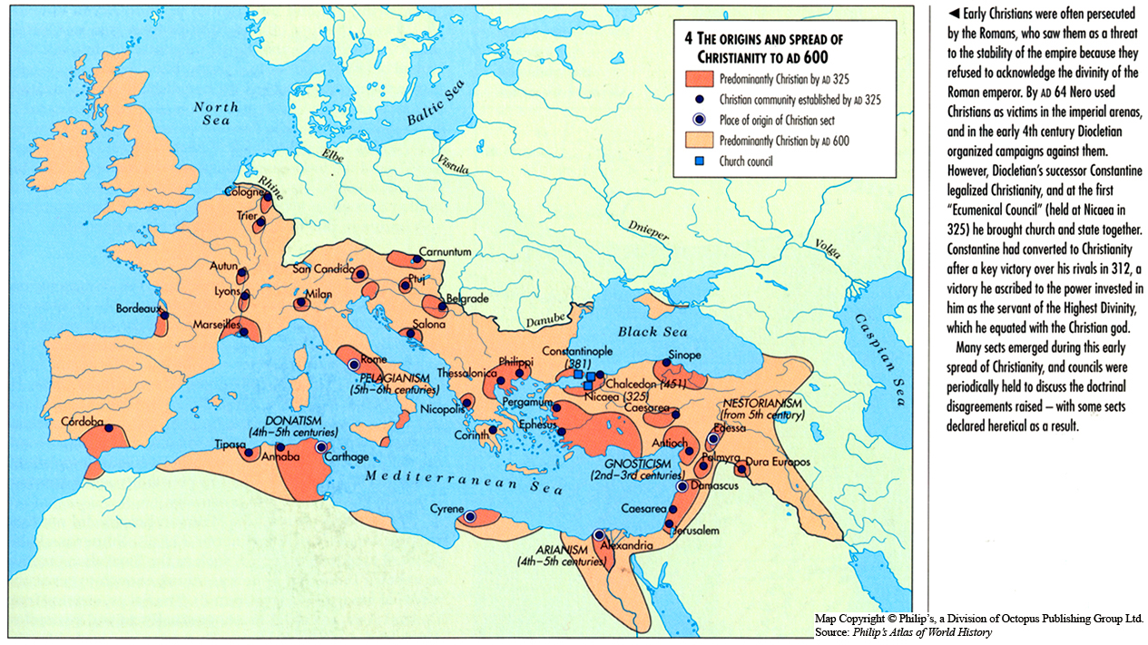

Conflict in Christianity.
Background
In the 1500’s a group of Spanish soldier explorers known as conquistadors, conquered lands in North and South American in the name of Spain. Hernan Cortes, who conquered the Aztec, and Francisco Pizzarro, who conquered the Inca, were perhaps the most famous. They brought with them their Catholic Christian beliefs and religious leaders ready to convert the native people living in the “New World.”
Document 1
Source: Hernan Cortes Letter to Charles V
They have a custom, horrible, and abominable, and deserving punishment…Whenever they ask anything of their gods, in order for their request to be fulfilled, they take many boys, girls, men, and women, and in the presence of the statues of their gods they cut open their chests. While they are still alive they take out their hearts and entrails. Then they burn the organs, offering the smoke as a sacrifice to their gods…No year passes in which they do not kill and sacrifice 50 souls at each temple in their kingdom… I did everything I could to steer them away from their false gods and to draw them to our Lord God. Montezuma agreed that I probably knew best…He said that as long as I taught the Aztecs our religion they would follow my directions. Therefore, I removed the statues of the false gods, cleaned the temples, and taught the people our religion. The rest of the Aztecs did not accept the new religion that I was giving them. They did make sure, though, that they did not sacrifice any more humans while I was in the city
Q: Why does Cortes oppose the religious beliefs of the native people? ____________________________
_____________________________________________________________________________________
Q: Why do you think the Aztecs would not change their religious beliefs?__________________________
__________________________________________________________________________________
Document 2
The following is a secondary source on the effect of Pizarro, a conquistador, on the last Incan Emperor.
High in the Andes Mountains of Peru, the Inca built a dazzling empire that governed a population of 12 million people. Although they had no writing system, they had an elaborate government, great public works, and a brilliant agricultural system. In 1532 before the Spanish arrived, a man named Atahuallpa had taken control of the Inca as Pizarro and his 180 soldiers appeared. Francisco Pizarro was the son of a Spanish gentleman sailed down the west coast of South America from Panama with his troops. Soon he heard firsthand accounts of the Inca empire and obtained Inca artifacts. Pizarro asked the king of Spain to give him money to conquer them. Because Hernan Cortes had recently brought the emperor great wealth through his conquest of the Aztec Empire he approved Pizarro’s plan. He also promised that Pizarro would receive the majority of the expedition’s profits. In 1531, he sailed down to Peru, landing at Tumbes. He led his army up the Andes Mountains and on November 15, 1532, reached the Inca town of Cajamarca, where Atahuallpa was enjoying the hot springs as he prepared for a battle. Pizarro invited Atahuallpa to attend a feast in his honor, and the emperor accepted. Having just won one of the largest battles in Inca history, and with an army of 30,000 men at his disposal, Atahuallpa thought he had nothing to fear from the bearded white stranger and his
180 men. Pizarro, however, planned an ambush, setting up his artillery at the square of Cajamarca. On November 16, Atahuallpa arrived at the meeting place with an escort of several thousand men, all apparently unarmed. Pizarro sent out a priest to convince the emperor to accept Christianity and Emperor Charles V. of Spain, and Atahuallpa refused, flinging a Bible handed to him to the ground in disgust. Pizarro immediately ordered an attack. Buckling under an assault by the terrifying Spanish artillery, guns, and cavalry (all of which were alien to the Incas), thousands of Incas were slaughtered, and the emperor was captured. Atahuallpa offered to fill a room with treasure as ransom for his release, and Pizarro accepted. Eventually, some 24 tons of gold and silver were brought to the Spanish from throughout the Inca empire. Although Atahuallpa had provided the richest ransom in the history of the world, Pizarro treacherously put him on trial for plotting to overthrow the Spanish and other charges. A Spanish court convicted Atahuallpa and sentenced him to die. On August 29, 1533, the emperor was tied to a stake and offered the choice of being burned alive or strangled by garrote (iron collar) if he converted to Christianity. In the hope of preserving his body for mummification, Atahuallpa chose the latter, and an iron collar was tightened around his neck until he died.
Q: What is your perspective on the treatment of Atahuallpa by Pizarro? _____________
Q: What facts from the article made it easy for the Spanish to overtake the Inca?___________

