Merchants and Artisans in Ancient Egypt
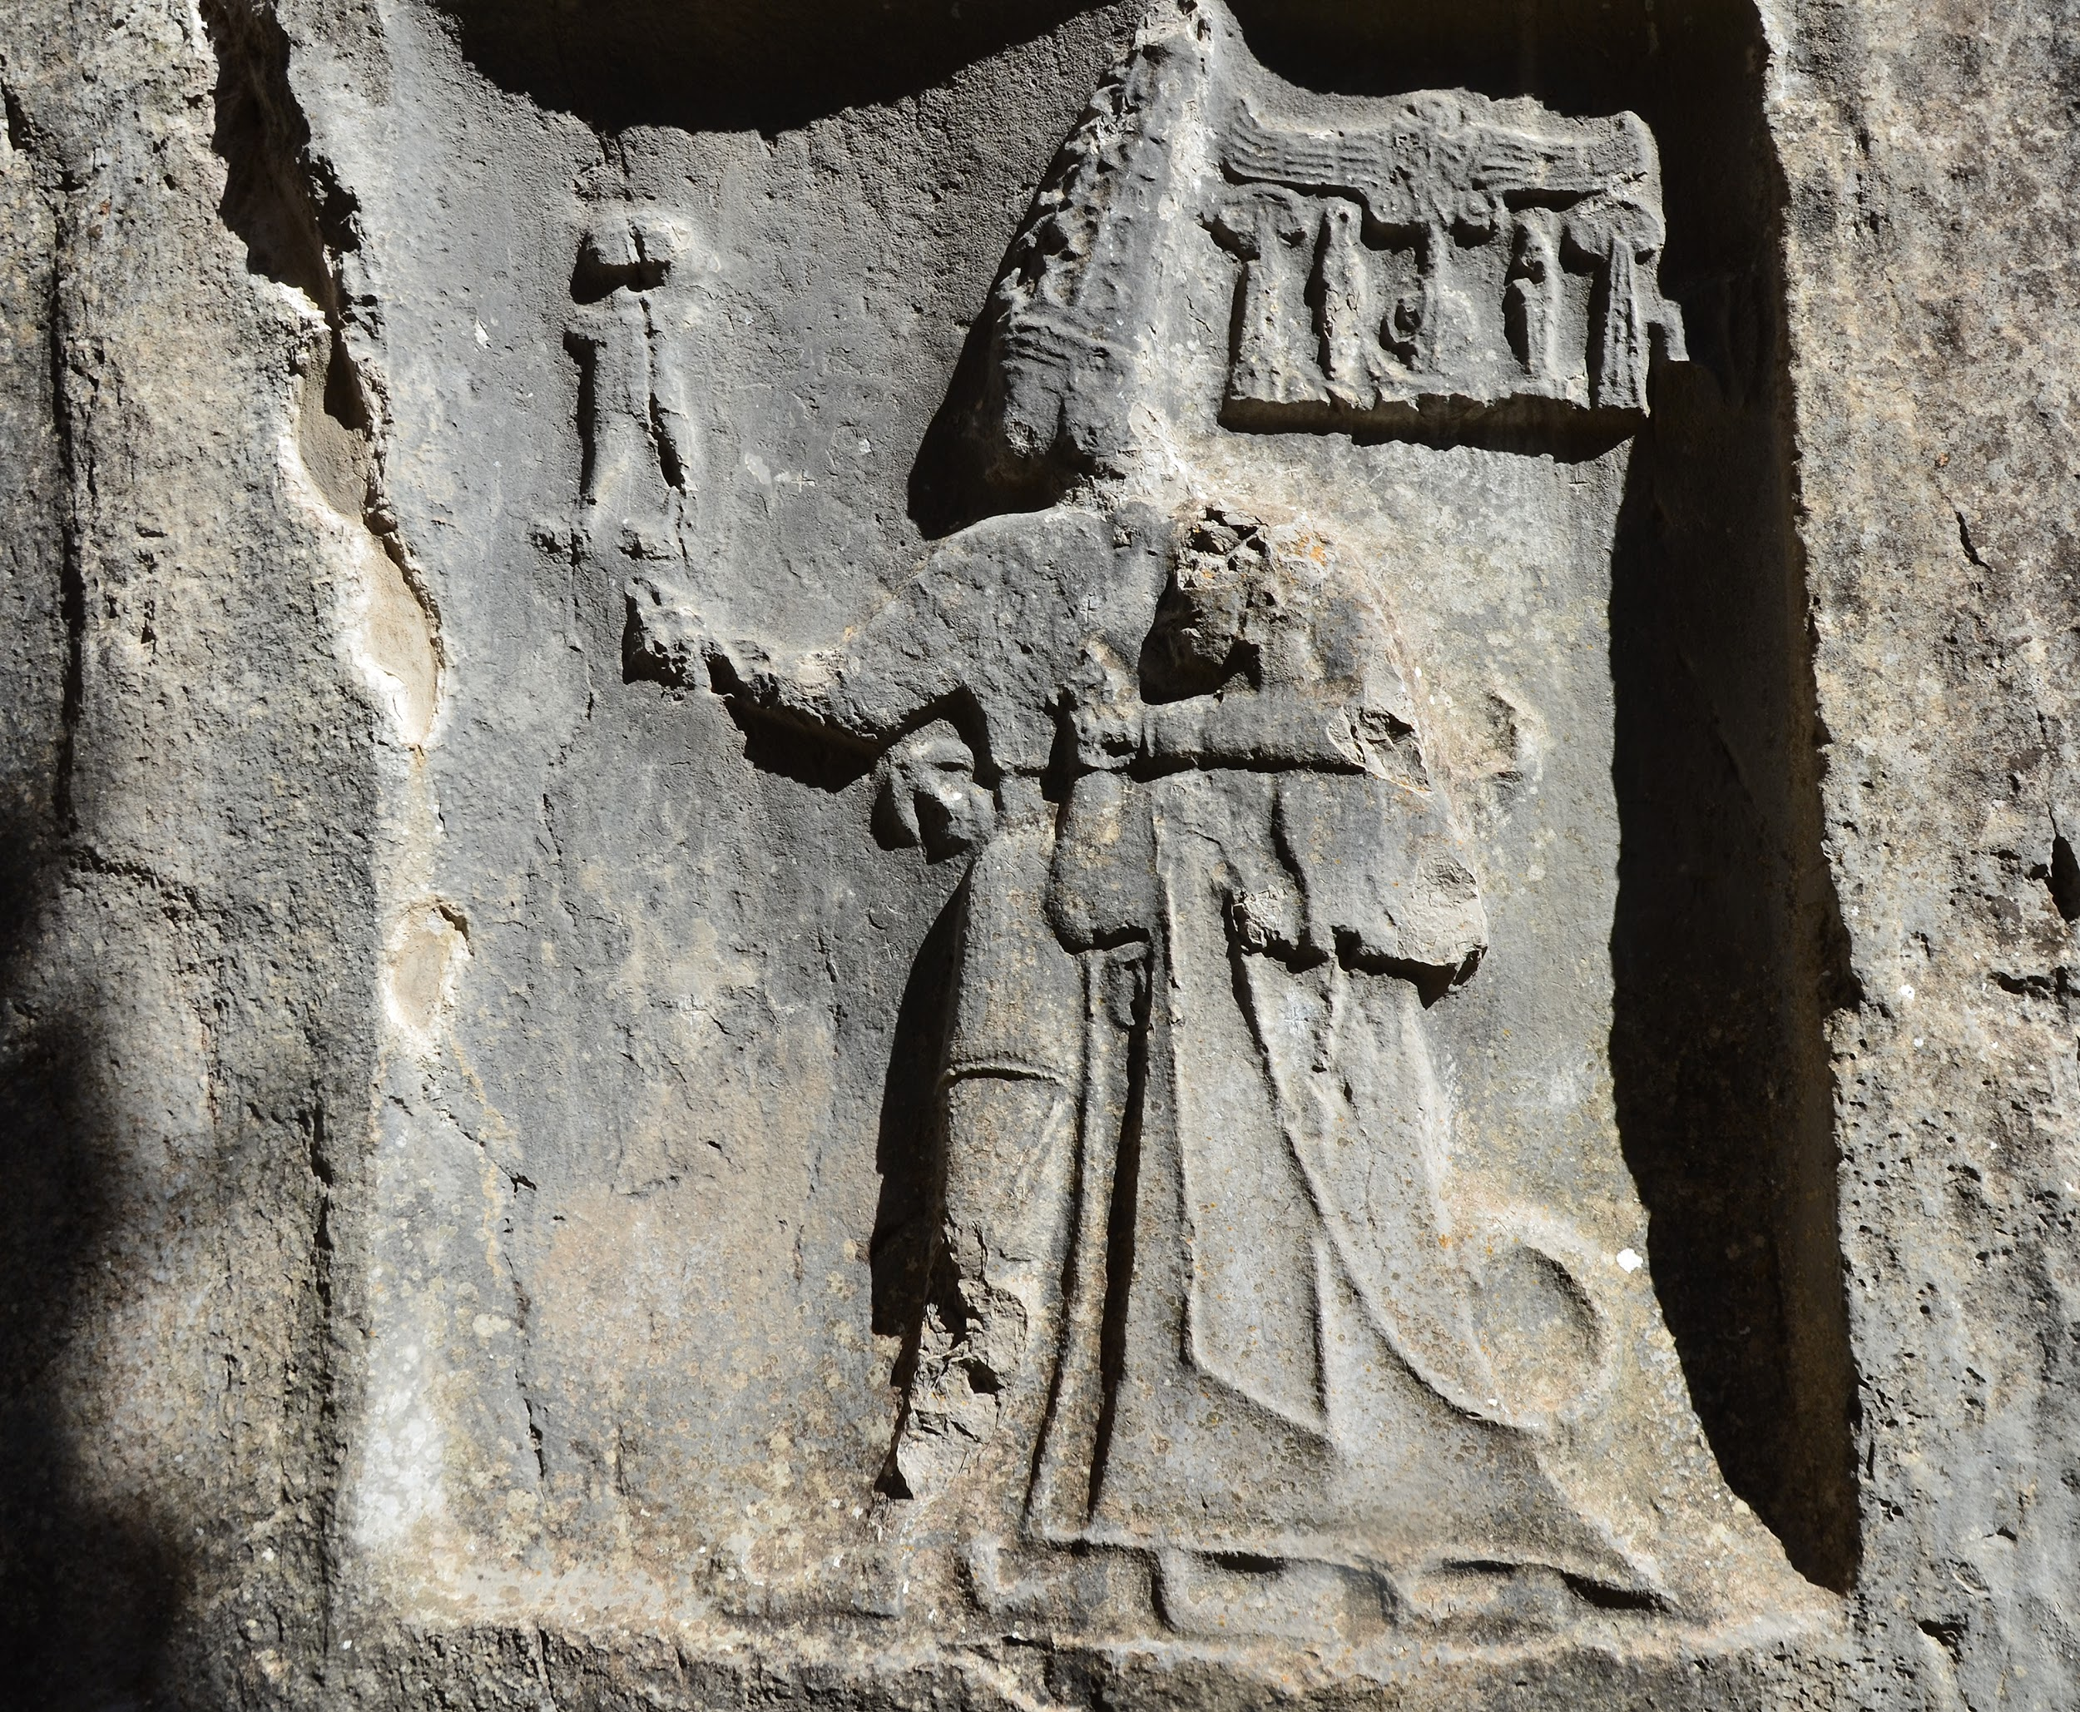
The average Egyptian merchant living in Ancient times owned a mud brick house, but would often travel to other nearby countries in order to trade. Some merchants would exchange native products like gold, papyrus, linen cloth, and jewelry for cedar, ebony wood, and panther skins. The merchants would return to Egypt to trade these items to the high class in exchange for grains and other goods. Farmers and fisherman could double as a merchant and sell their fish and other produce at the local market.
Recently it was discovered that the Nile was a common place for trade, with the use of small floating devices. This trading system could create a large amount of wealth, especially in foreign trade. The grain harvested often exceeded the amount needed for the Egyptian citizens and could be traded to nearby countries that cannot grow enough grains. This trade system functioned on barter, and was open to everyone, even women. Merchants who exchanged goods to royalty good make a good living, as certain foreign items were treasured in temples. Ancient Egyptian merchants had an important role in society because Egypt thrived on material possessions.
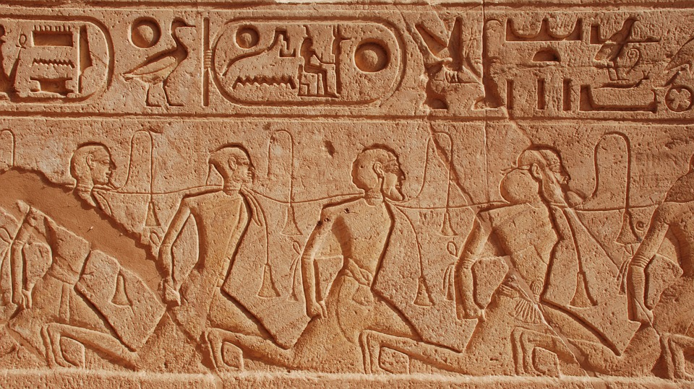
Ancient Egyptian art is full of symbolic meanings and importance. Much of Egyptian life can be deciphered through the study of Egyptian art. The artist however is often overlooked. Unfortunately almost all artisans were to remain anonymous. The daily life of an artisan can range greatly depending on his/her rank. The most talented artisans would work for the pharaoh, often building and decorating their tombs. These elite artisans were paid to live inside an exclusive village just for artisans. The pharaoh would provide the finances towards keeping stone masons, plasterers, draftsmen, sculptors, carvers, carpenters, painters and scribes in this little village. Like most roles, it was passed from father to son, and in case of weavers, it was passed onto women too.
Most times, artisans felt undervalued and would go on strikes if they did not receive payment on time (wheat, barley, etc.) Artisans could not always afford materials, such as clay, paints, metals, woods, ivory, bone, glass, flax, reeds, wax, leather and stone. They also had to make their own tools. Only those lucky enough to work in tombs could have their tools supplied for them.
Merchants and Artisans in Japan

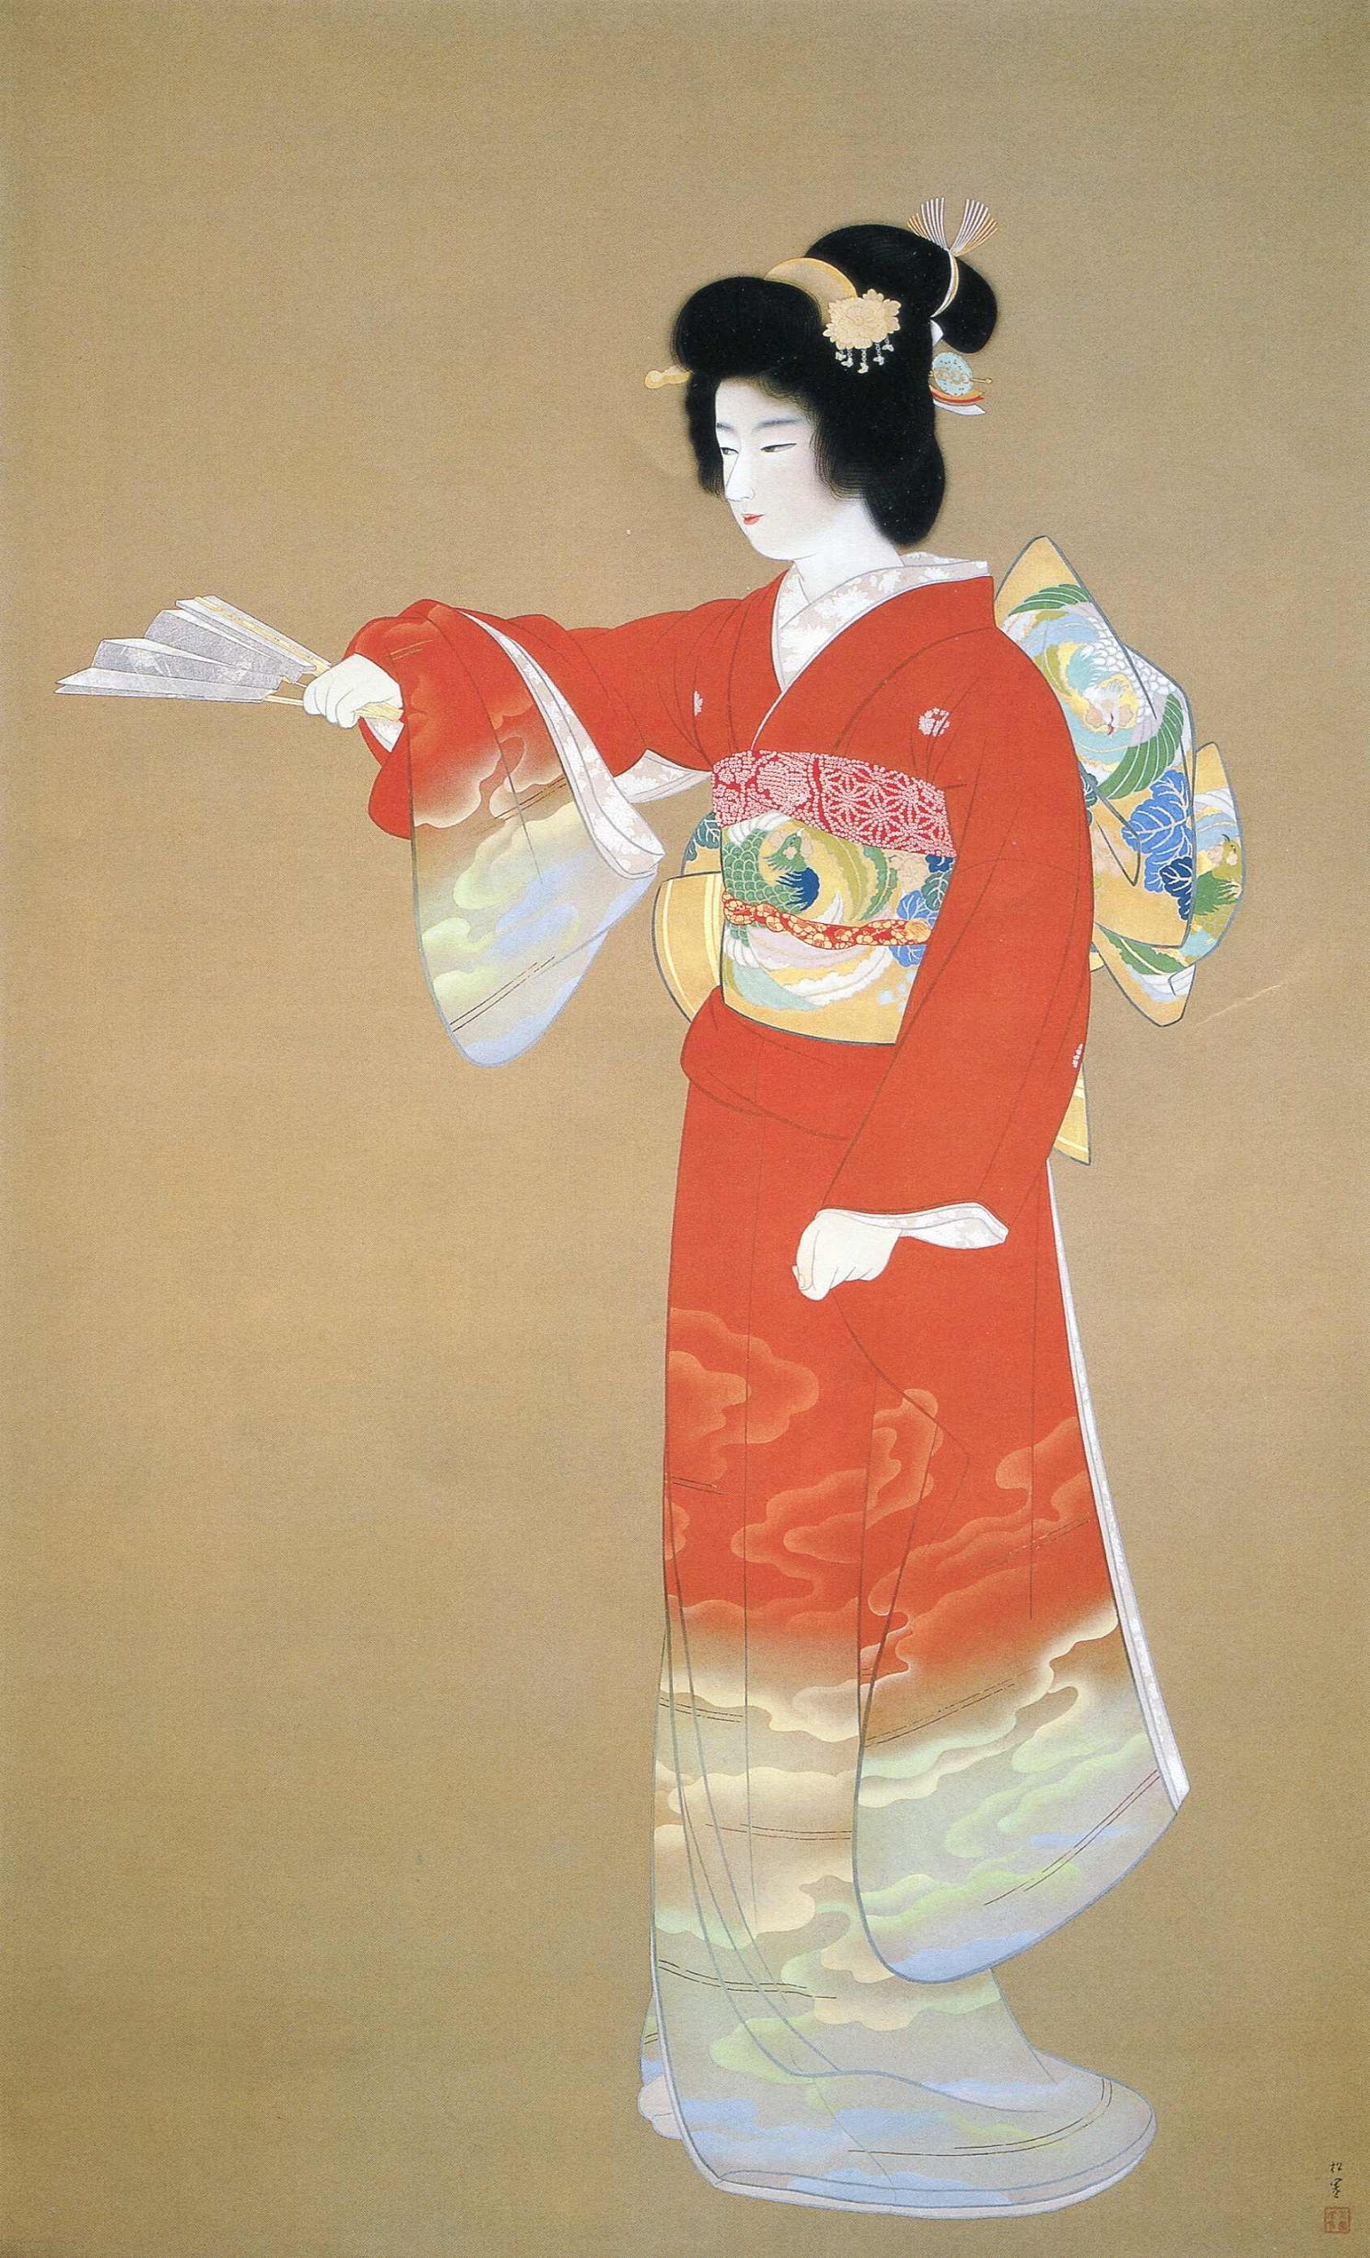
During the Edo period, the merchant class enjoyed a rise in social and economic status. Increasingly able to afford an education and the trappings of luxury, merchants broke social barriers, hobnobbing with samurai at the popular haiku and literary clubs. The clubs afforded the two classes a rare opportunity to mingle on an equal basis. Previously considered the dregs of society for their dealings with money, the merchants' new affluence encouraged the growth of art and helped spawn a culture more attuned to the common man.

The Merchants in Japan would travel all around Japan selling and buying goods from traders and other merchants. Merchants would travel by horse or in long distances boat. they were poor, but not as poor as Eta and would get very little time with their family. Merchants were very humble but would sometimes take advantage of someone with a bad deal. In the Feudal Period of Japan people didn't get paid Yen, they got paid gold pieces and silver pieces and sometimes food or arrow heads. Merchants would usually sing, whistle, hum or play music to attract people to buy his things. Merchants were dependant on other people’s work in order to make a living.

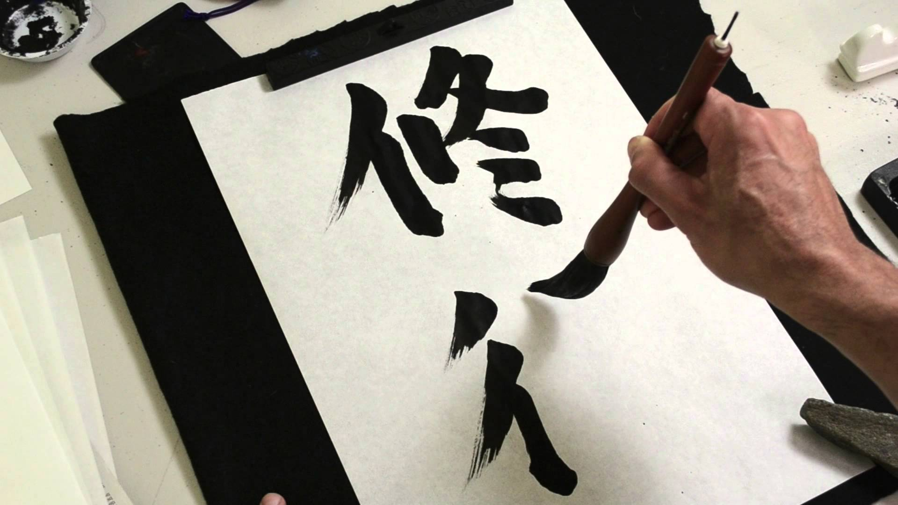
Craftsmen were builders, very skilled with tools and Measurements. They have built some outstanding things that have been here for over 800 years. The roofs in Japan were all built in the same design because it stops the snow building up on the roofs. Artisans could also be musicians, sculptors, calligraphers, painters, or actors. They would always be walking around or sitting at home painting, singing, dancing and sculpting and they would get paid for their work. Artisans work with metal and wood made many of them famous as Samurai sword makers.

During the early years of the Tokugawa era, artisans provided services to inhabitants of the daimyo castles throughout Japan. As the peace endured, cities sprang up around the castles, and with them, an increasingly prosperous artisan and merchant class that supplied the burgeoning townsmen (chonin). As community support for culture grew, the arts and entertainment flourished.

Ancient Mesopotamian Craftspeople & Merchants

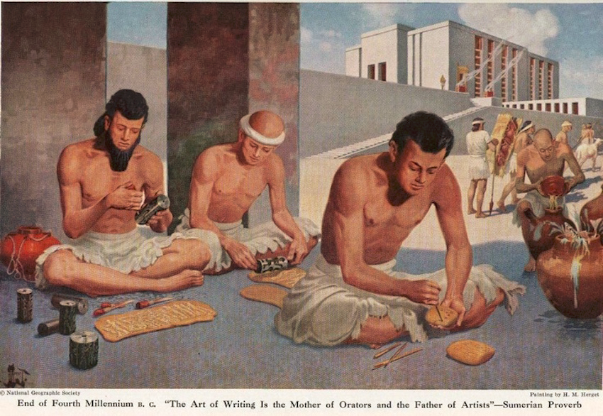
Mesopotamian society contained skilled craftspeople, merchants, and traders. Trade had a great impact on Sumerian society. Traders traveled to faraway places and exchanged grain for gold, silver, copper, lumber, and precious stones. These craftspeople, merchants and traders helped build the cities and increase the wealth of the city-states through trade with neighboring societies.
Mesopotamia was a region which did not have many natural resources. Therefore, the people who lived there needed to trade with neighboring countries in order to acquire the resources they needed to live.
Grain, oils and textiles were taken from Babylonia to foreign cities and exchanged for timber, wine, precious metals and stones. In addition, merchants from other countries traveled to Babylonia to exchange their goods.
Merchants used several different methods for transporting their goods depending on what they were transporting. For example, grain was quite bulky and was best transported on a boat, whereas precious stones were likely to be small, so they could be transported on foot or by donkey.

In the southern part of Mesopotamia, docks were built along the sides of the rivers so that ships could easily dock and unload their trade goods. The merchants traded food, clothing, jewelry, wine and other goods between the cities.
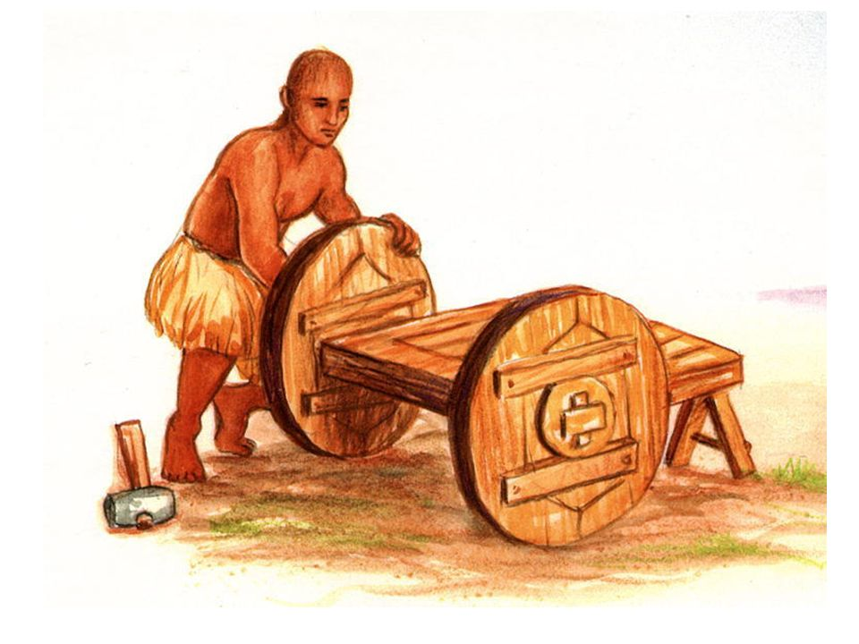
Sometimes a caravan would arrive from the north or east. The arrival of a trade caravan or trading ship was a time of celebration.
To buy or trade these goods, the ancient Mesopotamians used a system of barter. But they also used money. They didn't use paper money or coins. They used barley for local trade. Because barley was heavy, they used lead, copper, bronze, tin, silver and gold to "buy" things away from their local area. You had to borrow barley from a barley banker. The banker charged very high interest.

http://www.mesopotamia.co.uk/trade/home_set.html
http://www.mesopotamia.co.uk/trade/home_set.html

