Mrs. Vroome’s favorite place is Charlottesville, Virginia! Charlottesville is my favorite place because it has a beautiful landscape and reminds me of some of my favorite years spent living at college.
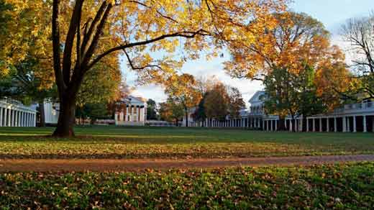
Region:
Charlottesville is part of the Blue Ridge Mountains region of Virginia. It is located in the mid- eastern part of the United States.
Place:
Charlottesville lies near the James River and close to the Blue Ridge Mountains. It has a humid subtropical climate and four distinct seasons. People come from all around the country and world to study in Charlottesville at the University of Virginia. People speak English and practice many different religions. There are many buildings that were designed by Thomas Jefferson in the 1800s. Many tourists travel to Charlottesville to visit Monticello, the home of Thomas Jefferson.
Movement:
Charlottesville is a college town so many ideas and information are moved through way of books, computers, classrooms, and students sharing information from the places they come from.
People move around on college buses, bikes, cars, and by walking.
Location:
Charlottesville is located about an hour from Richmond in the center of Virginia.

