Egyptian Pharaohs and Government Officials

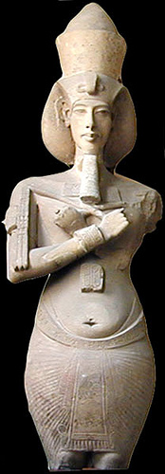
The pharaoh was the most powerful, wealthy individual in all on Egypt. The Pharaoh led the Egyptian people through politics, religion, and much more. He/she earned the title of ‘Lord of the Two Lands’ after Egypt was first united, and he also held the title of ‘High Priest of Every Temple.’ During his reign, he owned the entirety of Egypt.
Some of the roles of the pharaoh include making laws, collecting taxes, and defending Egypt from invasions. The pharaoh represented the Egyptian gods, and performing rituals and building temples in honour of the gods was perhaps his most important role. Pharaohs often made Egypt go to war, if they won, the defeated must bring their finest goods to their land.
Everyone worked for and worshipped the Pharaoh, for he was a god-king. Temples were built in their honour, luxury goods were traded with him, artwork was created in his name, and almost everything productive in Egypt was in some way connected to the pharaoh.
Throughout time, many great pharaohs have ruled and changed Egypt. An example of this would be Snefru. He managed Egypt’s military and wanted to strengthen the economy. He expanded trade and moved his empire to great lengths. The Bent Pyramid of Dahshur was created under his rule.

Government officials helped keep order in Egyptian societies. While the ruling Pharaoh had the most control of government affairs, there were many more people involved in the Ancient Egyptian government system.
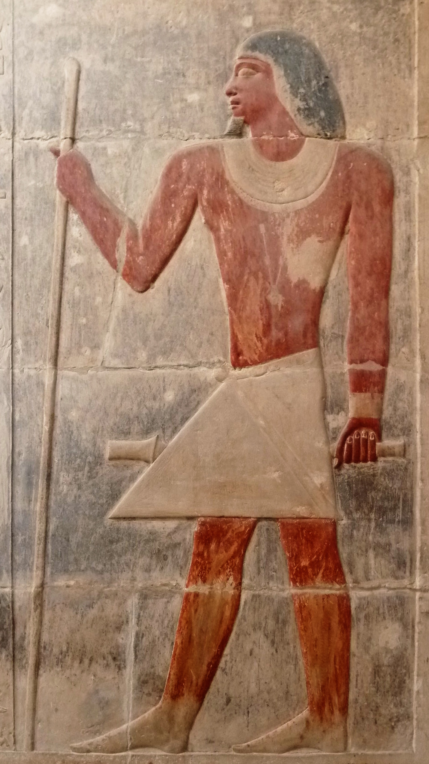
Egyptian law was based on common sense; they did not have set laws and would rather come to an agreement amongst the involved parties. Those involved in court affairs were of very high-ranking and had valued opinions.
Other government roles were the vizier, the chief treasurer, the tax collector, the minister of public works, and the army commander. A vizier was equivalent to a prime minister, and was the most important government official. Some of the roles of the government would be to build monuments, industry management, tax collection, supervising the army/navy, recording Nile patterns, and law. These officials lived in an upper class manner and were very privileged.

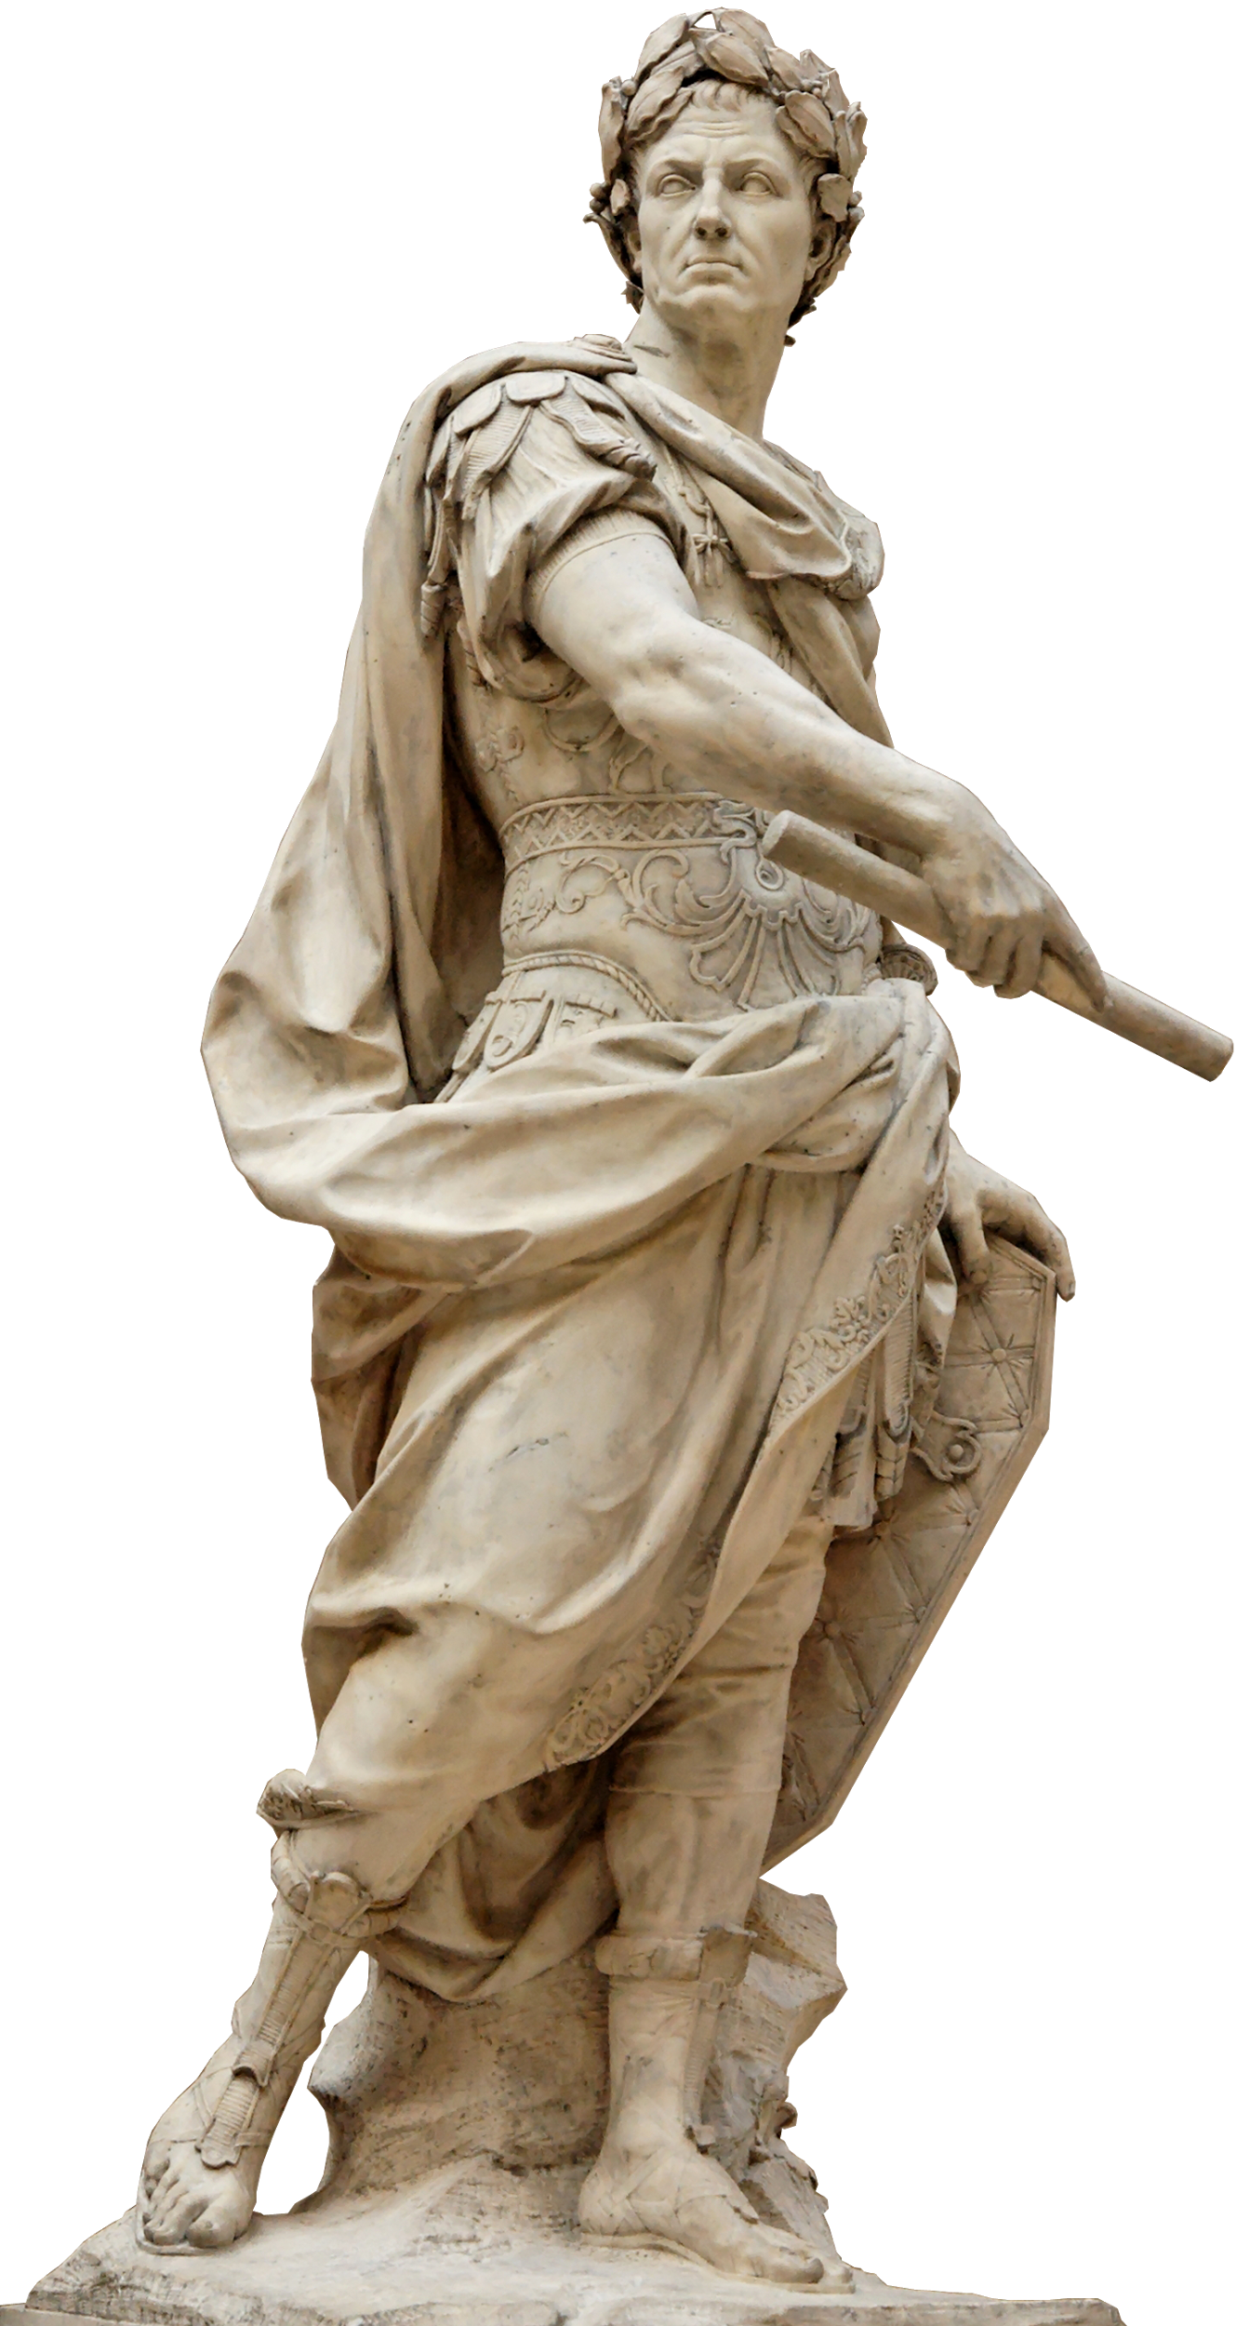
Emperors and Patricians of Rome

As absolute ruler of Rome and its enormous empire, the emperor and his family lived in suitable style. They stayed at the best villas, ate the finest food and dressed in only the most magnificent clothes.

Life was luxurious, extravagant and indulgent – the emperor’s family could spend their days enjoying their favorite pastimes, like music, poetry, hunting and horse racing.

Emperors were not chosen on the basis of their ability or honesty, but simply because they were born in the right family. Finally, once on the throne, there was no easy exit. Emperors had no elections or term limits, no early retirement or pension plans. It was a job for life, so if an emperor was mad, bad or dangerous, the only solution was to cut that life short. Everybody knew it, so paranoia ruled.

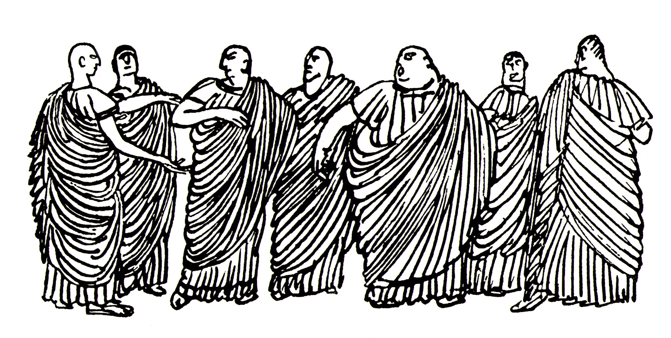
Ranked just below the emperor and his relatives, the patrician families dominated Rome and its empire. The word “patrician” comes from the Latin “patres”, meaning “fathers”, and these families provided the empire’s political, religious, and military leadership.

Most patricians were wealthy landowners from old families, but the class was open to a chosen few who had been deliberately promoted by the emperor.

The patrician class enjoyed few privileges: its members were excused some military duties expected of other citizens, and only patricians could become emperor. But this eligibility carried its own dangers: patricians could find themselves becoming wrapped up in palace intrigue. If they ended up on the losing side, they could easily lose their home, their lands and even their lives.

Apart from the plots and politics, however, members of both royal and patrician families faced little work or real responsibility and were blessed with a relatively charmed life – certainly compared to the other inhabitants of Rome at the time.

Mesopotamian Rulers and Nobles
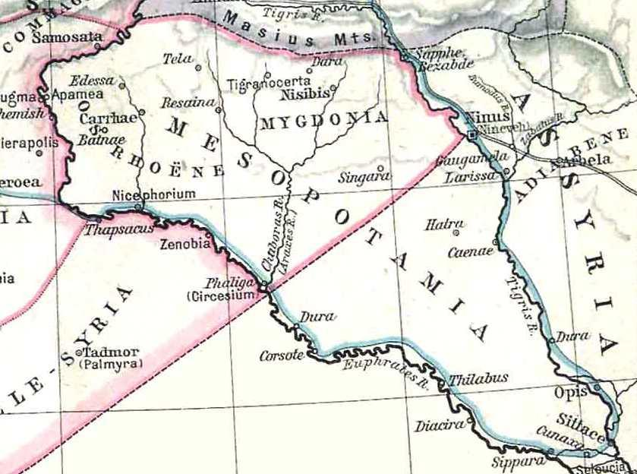
The government of the ancient Mesopotamians was an unusual form of government. There was a king and nobles who made the law and declared war and decided how to honor the gods. Then there was an assembly of the people who could overrule the king and say, this is not a good law, get rid of it, or we don't want to go to war, so stop it. The kings, if they were wise, would listen to the people.

The king of a city, region, or empire was thought to have a special relationship with the gods and to be an intermediary between the world of the divine and the earthly realm. The depth of a king’s relationship with his gods, and the god’s pleasure with his rule, was gauged by the success of the territory he ruled over. A great king would enlarge his kingdom and make the land prosperous and, by doing so, show that the gods favored him.

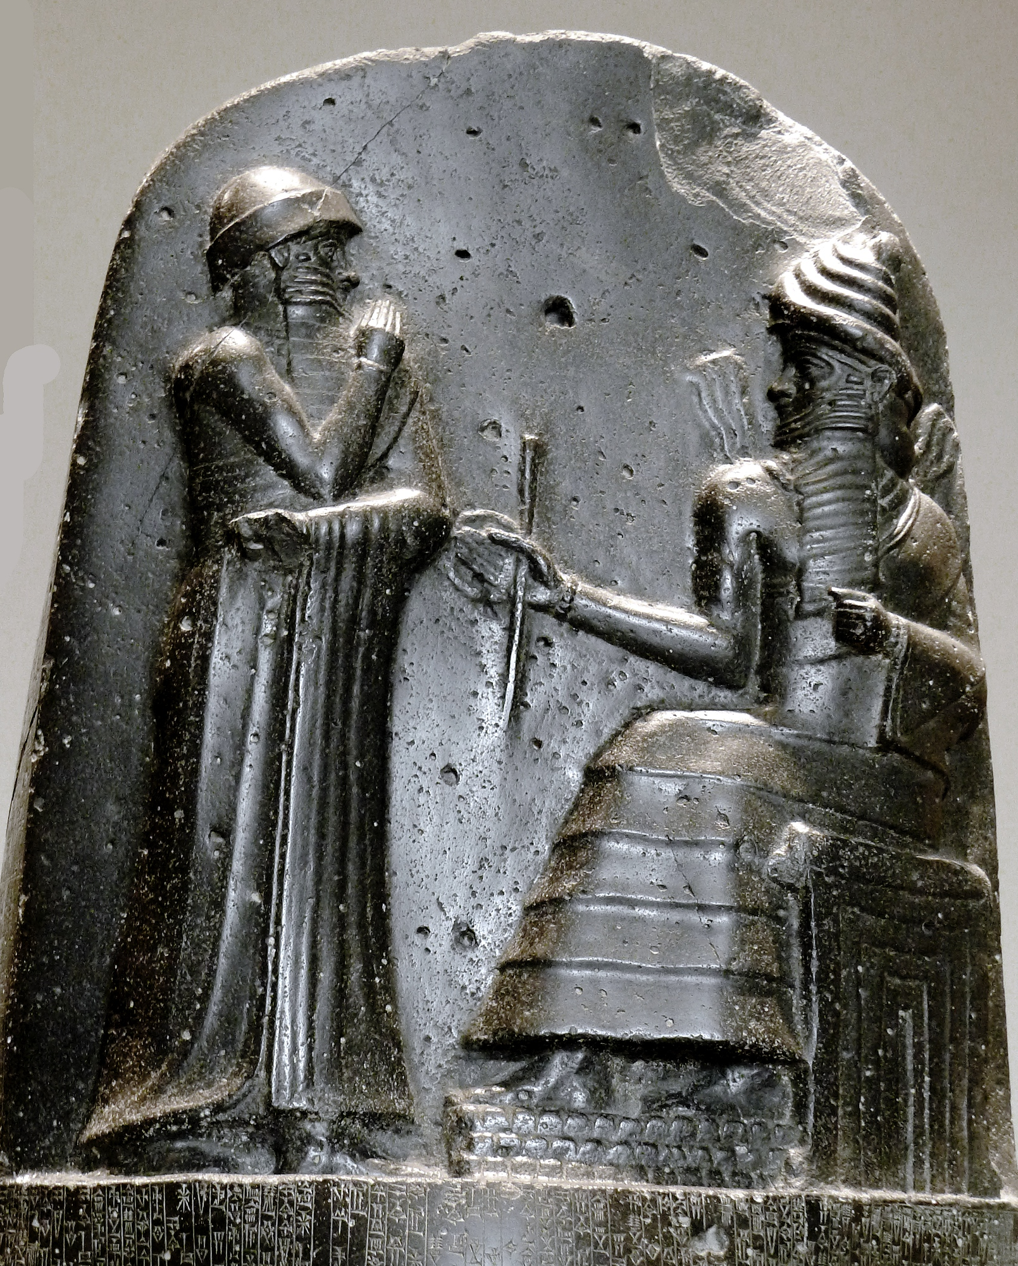
The upper classes of ancient Mesopotamia included kings and their families, priests and priestesses, ranking military officers, scribes and wealthier merchants and traders. The hereditary noble class were the kings, land-owning families and priests and priestesses and their families. Keep in mind that ancient Mesopotamia’s history stretches over 3000 years and includes many cultures: Sumerians, Akkadians, Babylonians and Assyrians. We can discuss these groups as one general culture as they all lived in the lands we call Mesopotamia and were very similar.

While not of the nobility, military officers, scribes and merchants who owned their own trading company were in the upper class. Their privileges were less than the nobles’ but greater than the commoners. Neither northern or southern Mesopotamia were rich in natural resources so merchants and their trade networks were necessary to obtain essential goods. Merchants obtained copper ore from the north in exchange for the manufactured goods of the south, for example.

