Ancient Americas Peasants
Mayan Peasants
Second to last were the peasants, who were mostly farmers. They did most of the farming, and spent most of the day in the field. The only tool they used was wooden hoes. The plow was not used in the Mayan time. When they weren’t farming, they were then helping to build pyramids for the gods. They were allowed to go to royal weddings and events, but they were not treated very respectfully. They also served as soldiers during war times.
Peasants: Peasants made up the bulk of Maya society. Craftsmen lived in the cities. Farmers lived outside the cities, in their fields. Peasants worked very hard. They did not live a life of luxury. Peasants were used as human sacrifice if no other people, like captured warriors, were available.

Aztec Peasants
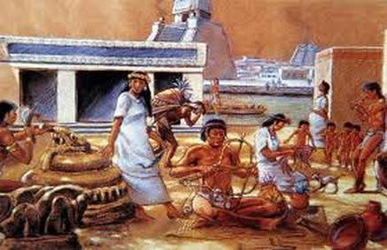
Peasants
This was the second lowest class in the social structure. They lived in small houses, and they worked in the fields and on farms. They technique they used for farming was terracing. The Aztec peasants had a noneconomic lifestyle.

Incan Peasants (Commoners)
The common people had no freedom. By Inca law, they could not travel on the roads. By law, they could not be idle. They had a little time each day for bathing and eating and sleeping, and the rest of the time, they had to be working.
The common people lived and worked in small groups or units. There were a dozen or so people in each unit. Each person in each unit had a job to do. If you did not do your work, you were breaking the law, and could be killed.
Most commoners, as usual, were farmers. The emperor controlled all the land and each group worked a plot of land given to them by a government official. That official let them keep food to feed themselves. The rest was given to the nobles and the emperor.
There was a tax on the food the common people kept. But the Incas did not use money. This "tax" was paid in labor. When the farmers were not farming, they were mining, or fixing the roads (the only time they could walk on the roads), or building something.
There were many laws that kept commoners tightly controlled. For example, if a man did not marry by the time he was twenty, a wife would be selected for him, and he had to marry her. Babies were left alone all day, by law, because care for crying babies took time away from work. The only training kids of the common people received was how to do a job. The job they were assigned as a child was their job for life.
The common people, except for craftsmen, did not live in the city. Each unit lived together in a hut in their field. Homes had no windows and no way to leave except by the front door. The door was covered only by a piece of leather or woven cloth. Inspectors checked to make sure all people were in their homes only when they should be.

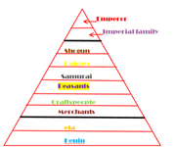
Japanese Peasants
The peasants in Japan were considered to be of higher rank than the craftsmen and merchants). The reason that they were the highest, rather than craftsmen or merchants was because they produced food that the upper classes were depended on. They were well respected, (more or less depending on how much food you made) and were considered an honored class.
However, being a Japanese peasant had its lows as well. You could not choose to be a peasant, and could only be born one. If you were a born peasant, you did not have the opportunity to become anything else but to follow the family tradition.
Although they were respected by the upper classes, it did not mean that they were treated well. They lived under a crushing tax burden, and had to give up the majority of the food they grew to the nobles, while only keeping whatever was left over for themselves. This was only a tiny bit-or even nothing for all the endless hard work that they did.
The Peasants were the largest class. According to the chart it is approximately 90% of the population; however, some sources report that the peasants were 75% of the population. This class included the farmers and fishermen. The peasants had no social status, no political power and were poor. They did have value as they produced food. The peasants paid taxes to the daimyos and shoguns in the form of work and crops, such as rice.
The Peasant Class was the lowest class and possessed very few or no powers at all. They performed day to day working which a common man does to earn a livelihood.

Peasants of Egypt
Peasants made up the lowest level of the social pyramid of ancient Egypt. They were the farmers, construction workers, and the unskilled laborers. As construction workers, peasants helped build the monuments and pyramids for the pharaoh.
Peasants lived with the fewest comforts of the social classes, and lived in the simplest mud-brick houses. Where the pharaoh and the upper classes had feasts with tons of food, peasants lived off of a simple diet, and at times were forced to eat papyrus because of famine.
Farming
Despite being the lowest social class, ancient Egyptian society depended on the peasants. The peasants were the farmers who grew the crops that supplied everyone's food. The life of a farmer revolved around the three seasons of the Nile River.
The flooding season was June to September. The Nile River flooded the grounds and fertilized the fields. This is when they helped build pyramids.
The planting season happened in October. They sowed their fields with mostly wheat and barley.
The harvest season started in March, and peasants worked all day cutting down plants and gathering them.
Reflections
Fairness and Equality
Ancient Egyptian belonged to the social class they were born into and had little chance to move up to a higher class. Being able to move up in social class meant better quality of life. The ancient Egyptians believed in their social classes since it kept order in society. It gave each class duties and jobs that helped the civilization as a whole.

