Ancient America Priests
Maya
The priests and the nobles made up the upper class of the Maya people. The nobles ran the government. The priests ran everything else. Some priests also held government jobs. The nobles might have believed they were in charge, but it was the priests who had real power.
The Maya people believed their priests could talk to their gods. The priests told the people what the gods had said. No matter what your class, there was no arguing with the gods.
The priests told the people when to plant, when to harvest, when to marry, who to marry, when to make a personal sacrifice, how to behave, and when to go to war. The priests were incredibly powerful.
Festivals were held every 20 days in each Maya city, to honor the many Maya gods. The priests of each city conducted the religious part of these festivals. They danced on the steps of the temple, wearing elaborate and rather scary costumes, so that the people could see them communicating with the gods.
There was one type of priest who acted as teachers for the children of the nobles. These priests taught math, science, astronomy, medicine, writing, and of course religion.
Aztec
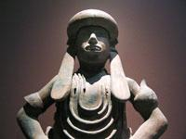
PRIESTS AND PRIESTESSES
The life of an Aztec priest was very hard and uncomfortable even though they were treated as nobles and were very important to Aztec society. Aztec priests had many responsibilities including: watching the planets and stars to prophesize and sound the time, keeping track of eclipses and other planetary events, naming certain constellations, computing the movement of stars and planets for predictions of their future positions in the sky, reading the calendar, divining the incantations to the gods and horoscopes, divining horoscopes for newborns to see if their sign was lucky or not, and checking the horoscopes of engaged couples to see if they were compatible, making offerings and sacrifices to the gods, sacrificing victims on the sacrificial stone, and drawing blood.
The priests of Tlazolteotl heard confessions, went to war with the warriors to hear their confessions, and took the boys in training out into the dark on nightly walks to gather dangerous creatures. The life of an Aztec priestess was equally very hard and uncomfortable. Priestesses also performed many ceremonies, prayers, songs, incantations, and divinations in honor of the gods as well. Their responsibilities included reading the calendar and interpreting the Sacred Calendar, divining the incantations to the gods, reading horoscopes, and making sacrifices and offerings to the gods.

Inca
Inca Priests and Priestesses
-Priests and priestesses were thought to be able to do the bidding of the gods, so they were highly honored and often part of the royal family.
-Priestesses were expected to perform the hair combing ceremony which celebrated the coming of age for a girl.
-A girl would become a women during her hair combing ceremony and would choose her new name.
-The most beautiful and talented girls were sent to Cuzco to become princesses or the brides of rulers.
-When the ceremonies were performed, many people gathered to celebrate with dancing that generally followed all of the religious ceremonies.
-The priests were mainly advisers and counselors to the royal family, but they would counsel others on occasion.
-They also helped heal the sick and performed ceremonies.
-They also did what most priests do today, telling people about the gods and relaying messages and good or bad fortune to the people.
-The Sapa Inca led the government and religion.
-The high priest was a brother of the Sapa Inca. He and his priests came from the upper classes.
-They also helped the government. Other priests worked at the temples in the villages. They did the rituals, they led worship, and they offered sacrifices.
-Some priests predicted the future.
-Beautiful young girls went to live at the temple. They learned to weave fine cloth. They also brewed beer from maize (corn).Some of these girls married nobles. One might even marry the Sapa Inca. Others stayed in the temple and became priestesses.

Egyptian Priests
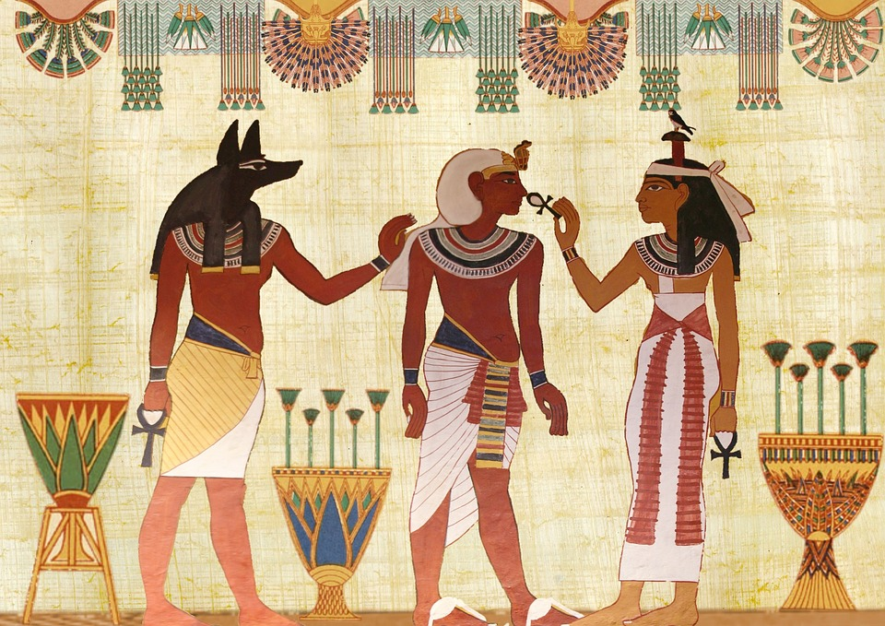
Religion was extremely important to the Ancient Egyptians, therefore those who spoke to the gods and studied them were also important. The temples were places where religious ceremonies were held. They were also schools, universities, libraries, and centers of administration, workshops, farms and granaries.
Priests held a high ranking in Egypt, enjoyed their wealth and power, but embraced a mundane life as part of their practice. Priests were first introduced because Pharaohs could not perform in every ceremony taking place, and selected men to take his place at these temples.

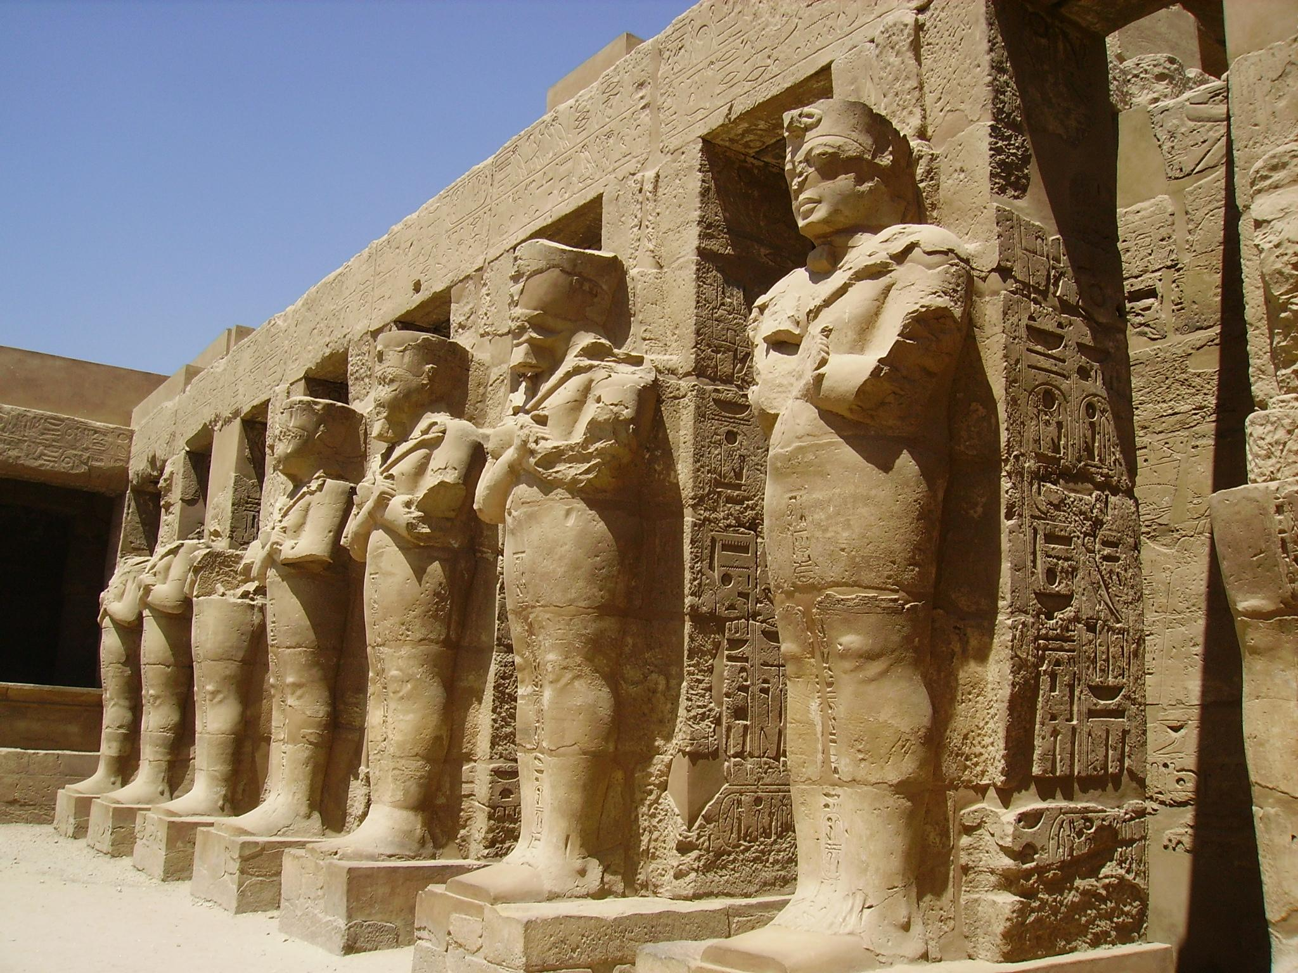
Some jobs of a priest are school teaching, supervising artisans, and guiding those in need. The priests were responsible for the process of getting bodies ready to move on to the afterlife. They conducted the burial ceremonies and the procession to the tomb. At the tomb, the priests were also responsible for the opening of the mouth ceremony. This is the ceremony that the ancient Egyptians believed would restore the deceased ability to eat and drink in the afterlife.

In order to achieve status as a priest/priestess, one must become appointed by the king or take after their father if he is too a priest. The majority of these roles were taken by men, but there were very few women who were accepted into the priesthood.

The roles of a priest differ on the gender of the priest, and their social status. Often the roles of the priest were rotated, and one would only serve as a priest three months out of the year. Near the end of Ancient Egyptian society, the priesthood had grown from the hundreds into the thousands. Many classes were established, some higher ranking priests held large amounts of land, stone houses, personal farmers, and many other luxuries.

Mesopotamian Priests

The Sumerians believed that their gods had enormous powers. Gods could bring good harvests or disastrous floods. They could bring illness, or they could bring good health and wealth. The Sumerians believed that success in life depended on pleasing the gods. Every Sumerian had to serve and worship the gods.
Priests, people who performed or led religious ceremonies, had great status in Sumer. People relied on them to help gain the gods’ favor. Priests interpreted the wishes of the gods and made offerings to them. These offerings were made in temples, special buildings where priests performed their religious ceremonies.

Because of their status, priests occupied a high level of respect in Sumer’s society. In fact, priests were ranked just below kings in the power they held. The kings of Sumer claimed that they had been chosen by the gods to rule.
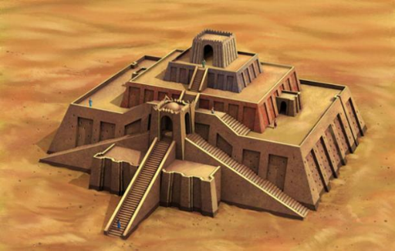
In the center of each town, was the Ziggurat. The Ziggurat was a temple. The ancient Sumerians, believed their gods lived in the sky. In order for the gods to hear better, you needed to get closer to them. Ziggurats were huge, with built in steps. Ziggurats had a wide base that narrowed to a flat top. When the Babylonians took over in the south, and the Assyrians in the north, ziggurats continued to be built and used in the same manner as they were in ancient Sumer.The Ziggurat was the tallest building in the town. From its top, you could see well into the farmlands that surrounded the city. Religious ceremonies were held on top of the Ziggurat. Each day, people would leave offerings to the gods of food, cloth, and wine on the steps of the ziggurat. The priests would collect and use these gifts since they were the representatives of the gods on earth.
Priests were very powerful and important. They told people how to behave to keep the gods happy. Priests in Sumer (and in Babylon) were also the local doctors. If you got sick, you sent for a priest. The priests shaved their heads so that everyone knew they were priests.

Holt, Rinehart and Winston, Holt Textbook: Eastern World
http://mesopotamia.mrdonn.org/religion.html

